# **CONFIGURING GPIO PINS AS INPUTS - CONTROLLING LEDS FROM PUSH BUTTONS**

### **Objective**

Learn how to ‘read’ values from the Raspberry Pi GPIO pins, make dimmable LEDs with PWM and Push Buttons.

## **COMPONENTS:**

1) RPi 3

2) Breadboard

3) 330 Ω Resistor x 2

4) LED x 2

5) Push Buttons x 2

6) Connecting Wires

## Push Button

A pushbutton is a simple switch mechanism which permits user generated changes in the state of a circuit. Push Button usually comes with four legs. As you can see from the picture below, legs are always connected in groups of two. When the pushbutton is pressed all the 4 legs are connected

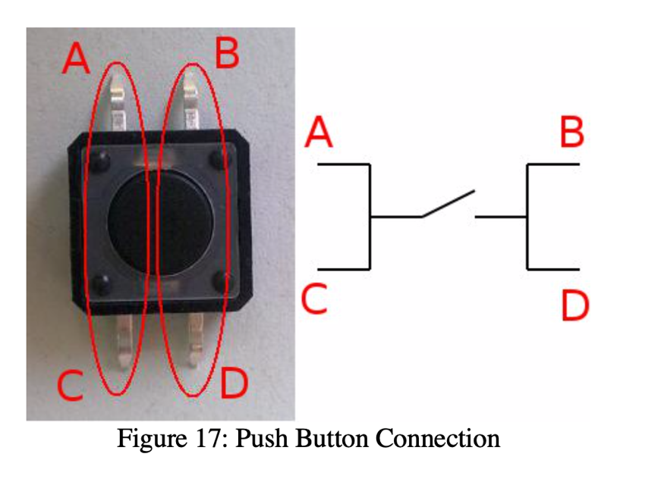

## CIRCUIT DIAGRAM:

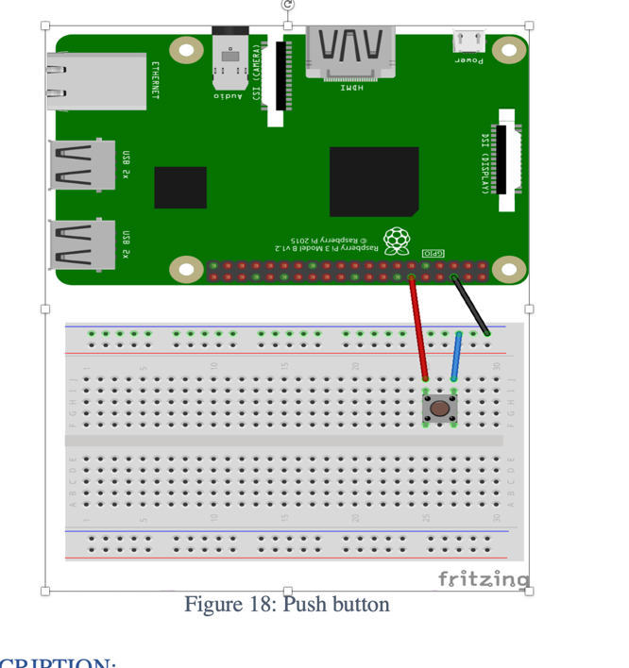

Code:

# Only button as input  
  
from time import sleep # Library will let us put in delays  
import RPi.GPIO as GPIO # Import the RPi Library for GPIO pin control  
  
button1_pin=12 # Button 1 is connected to physical pin 12  
  
GPIO.setmode(GPIO.BOARD) # Use Physical Pin Numbering Scheme  
GPIO.setup(button1_pin,GPIO.IN,pull_up_down=GPIO.PUD_UP)

# Make button1_pin an input, Activate Pull UP Resistor  
  
while(1): # Create an infinite Loop  
 input1=GPIO.input(button1_pin)  
  
 if input1==0: # Look for button 1 press  
 sleep(.1) # Delay  
 print ('Button 1 Pressed') # Notify User